Ransomware Attack Simulation
Group 3 – Fnu Abdullah and Ahmed Hussain
Abstract
Ransomware continues to pose a major cyber threat today, encrypting vital data and demanding payment for restoration. This project simulates a ransomware attack on a Kali Linux virtual machine. It builds custom encryption tools, infect via USB Rubber Ducky, and sets up multi-layered defenses including monitoring, detection, and mitigation. The action component creates Python-based encryption and decryption GUI screens using crypto libraries to recursively encrypt a specific folder ("personal_Fa0337"). The infection of the attack happens through a precompiled Rubber Ducky payload that downloads and runs setup scripts in the background. Auditd and Wazuh are used for monitoring to log AppArmor denials and file integrity monitoring (FIM), respectively. Detection integrates custom Wazuh rules to identify encryption patterns, mass modifications, and AppArmor blocks, triggering alerts for potential ransomware. Finally, mitigation uses AppArmor profiles to confine Python processes, denying access to protected directories, combined with Wazuh active responses to terminate malicious processes. Backup and recovery strategies discussed involve encrypted off-system backups for data restoration. The project demonstrates successful attack simulation without defenses, followed by active containment when defenses are enabled, achieving zero false positives in legitimate operations. This work provides a reproducible educational setup for studying ransomware behavior and evaluating layered security controls. This project also emphasizes the importance of proactive monitoring, policy enforcement, and repeated backups in mitigating ransomware. Future extensions could incorporate machine learning for improved detection, as well as additional security technologies and policies.
Introduction
Ransomware attacks have become complex operations that disrupt organizations and key infrastructures. Incidents, such as the 2021 Colonial Pipeline ransomware breach, show the impact of such attacks, leading to operational downtime, financial losses, and compromised data integrity. The rise of Ransomware-as-a-Service (RaaS) platforms has also further made these attacks easier, letting people with minimal technical skills to perform cybersecurity attacks.
This project is divided into two phases: simulating a realistic ransomware attack in an isolated VM environment, and implementing and validating mitigation techniques with runtime monitoring and detection techniques.
This project is conducted entirely within a Kali Linux virtual machine, and the simulation targets a structured directory, called personal_Fa0337 containing sensitive files. The attack vector uses a USB Rubber Ducky to deliver and execute encryption code without any user interaction.
The defense strategy includes:
- AppArmor for application confinement
- Wazuh for monitoring and rule-based detection
- Active response for automated containment
- Offline backups for recovery
By using these techniques, the project demonstrates that even simple, well-configured tools can neutralize ransomware threats before damage occurs.
Related Works
Studies on ransomware have grown, focusing on tactics, detection methods, and mitigation strategies.
In the 2024 Evolution of Ransomware paper, the authors trace the development of ransomware from mass-distribution campaigns to targeted attacks, emphasizing the rise of Ransomware-as-a-Service (RaaS) and double extortion methods. Among the key findings are the use of cryptocurrencies for ransom payments and the targeting of critical infrastructure. The paper’s recommended mitigation strategies emphasize strong cyber hygiene, regular backups, endpoint detection, user training, and multi-layered defenses, aligning with this project’s development of AppArmor and Wazuh integration. [1]
Another mitigation strategy is to use machine learning for early detection of ransomware attacks. This is discussed in detail in the paper “A Comprehensive Literature Review on Ransomware Detection Using Deep Learning,” where it highlights the surge in attacks through Ransomware-as-a-Service (RaaS) and the role of neural networks in analyzing preprocessed data. Models such as TextCNN, LSTM, and GANs are examined, demonstrating high detection rates but requiring robust datasets. These insights can inform potential future machine learning extensions to our project. [2]
"Ransomware: Recent Advances, Analysis, Challenges and Future Research Directions" paper explores how to stop attacks by controlling access, saving data, and managing keys. It also looks at spotting threats by using ML on APIs, checking file randomness, and watching network traffic. Challenges include evasion tactics and limited datasets. Future ideas include shared learning and using blockchain. [3]
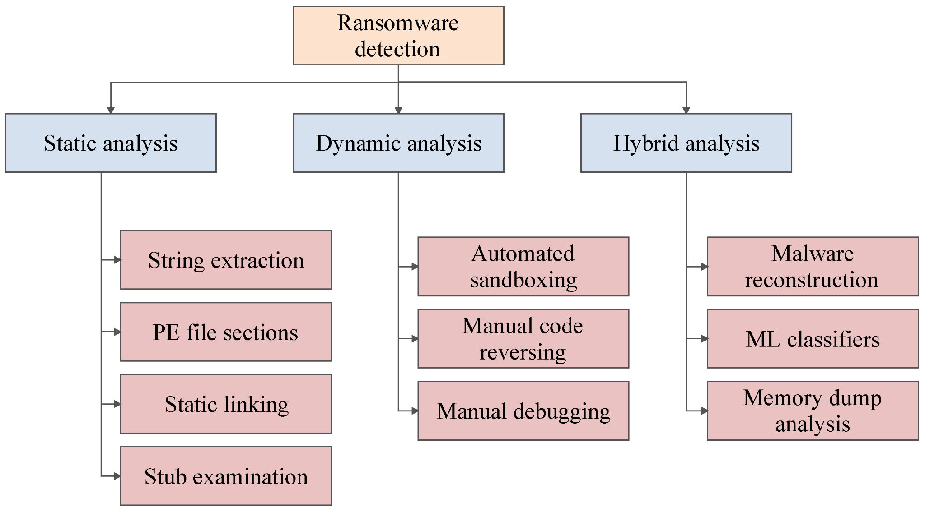
In 2022, a paper titled “Ransomware Detection, Avoidance, and Mitigation Scheme: A Review and Future Directions” was published, proposing the DAM framework, which classifies detection methods into static, dynamic, and hybrid approaches, shown in the Figure. Additionally, a Djvu case study emphasizes the importance of early detection and regular backups, with future directions focusing on AI and automated responses. These insights guide our implementation of Wazuh’s active-response mechanism. [4]
Source: https://www.mdpi.com/2071-1050/14/1/8, Figure 5
These works focus on the need for integrated defenses, validating our simulation's focus on monitoring, detection, and mitigation.
Approach
1. Action Component: Encryption and Decryption
The ransomware logic is implemented in two Python modules. The first one is the client-encrypt.py, which prompts the user for a ransom password via a GUI (Tkinter), derives a cryptographic key using PBKDF2-HMAC, recursively traverses /home/kali/Desktop/personal_Fa0337 using os.walk(), encrypts each file with Fernet (AES-128 in CBC mode with HMAC) and appends .enc, securely deletes the original using os.remove(), and uploads the encrypted key to Supabase via the store-credentials.ts edge function. The second module is the decrypt component, client-decrypt-gui.py, which verifies the entered password against Supabase (verify-password.ts), and retrieves and decrypts files if the authentication succeeds. All scripts are hosted in the server-type-arch/ directory and executed within an isolated virtual environment.
2. Infection Component: USB Rubber Ducky Delivery
The infection mechanism uses a Hak5 Rubber Ducky to automate payload deployment using the inject_script.txt, which essentially opens the terminal and downloads the setup.sh, executes it, and exits the terminal. The setup.sh file creates a hidden directory and Python virtual environment, installs dependencies – cryptography, requests, and tkinter (using the requirements.txt), executes client-encrypt.py in the background, and logs activity to setup.log. The precompiled inject.bin is put in Github for instant simulation.
3. Monitoring Component
System activity is monitored using two complementary tools – Auditd and AppArmor, which sets a watch rule in /etc/audit/rules.d/apparmor.rules which leads to denied operation being logged to /var/log/audit/audit.log with apparmor="DENIED"; and, Wazuh File Integrity Monitoring (FIM), which is configured in /var/ossec/etc/ossec.conf with the directory listed as HTML tags. In this way, all the file events are recorded in /var/ossec/logs/alerts/alerts.log if anything is modified.
4. Detection Component
Custom Wazuh rules in /var/ossec/etc/rules/local_rules.xml detect ransomware indicators, such as, encryption file pattern, mass file modifications, access control violations, or critical data protection breach. Rules are reloaded with sudo systemctl restart wazuh-manager.
5. Mitigation Component
A custom profile is defined at /etc/apparmor.d/usr.bin.python3 which prevents any Python process from reading, writing, or executing within protected paths. The rules can later be tightened to prevent other processes from accessing them. An active response mechanism is also implemented, beyond AppArmor, that runs when a high-severity alerts fire to act as a last line of defense if AppArmor or other controls fail. When triggered, the active response locates the offending process, terminates it, quarantines the suspected artifact, and notifies administrators so the incident can be investigated. The script to run is located at /var/ossec/active-response/bin/ransomware-response.sh, and the ossec configuration is linked to the file with a command (please refer the GitHub for the code).
The Backup and Recovery principles that should be followed for best practices to ensure data can be restored without paying ransom are the 3-2-1 backup rule, where 3 copies of important data should be stored in 2 different storage media, and one of them should be off-site. The target directory could also be implemented to have daily backups using incremental snapshots, via rsync, LVM, or Btrfs, to an encrypted, immutable storage location such as an external USB drive or cloud storage bucket on AWS. Keeping backups disconnected prevents ransomware from encrypting them.
The recovery process if the attack succeeded is to isolate the infected system, review Wazuh and audit logs, re-image and reinstall the OS, and verify AppArmor and Wazuh in enforce mode before reconnecting, restore data from backup, and validate file integrity.
Results
The ransomware simulation was evaluated in two distinct scenarios: defenses fully disabled and defenses fully enabled. All experiments were conducted within an isolated Kali Linux virtual machine, targeting the directory /home/kali/Desktop/personal_Fa0337, which contained a structured set of test files including the project description and lab manuals distributed across three subdirectories.
When defenses were disabled, the attack succeeded completely. Upon insertion of the USB Rubber Ducky, the payload executed silently in the background, downloaded the encryption script, and recursively encrypted every file in the target directory. Encryption was completed in approximately 8 to 12 seconds, The ransom GUI appeared as intended, and decryption was only possible by entering the correct password verified through the Supabase edge function. No system-level interference occurred, and the attack left no opportunity for recovery without the attacker-controlled key.
In contrast, when all defensive measures were active, the attack was stopped before any file could be modified. AppArmor enforced the custom profile on /usr/bin/python3.13 and blocked the first write attempt at the kernel level, resulting in an immediate “Permission denied” error. This denial was logged in /var/log/audit/audit.log with an apparmor="DENIED" entry. Within 3-6 seconds, the attack was blocked. As a result, no file was encrypted, and no ransom demand appeared, and system integrity remained fully intact.
These results clearly demonstrate that a layered defense architecture, combined with preventive access control via AppArmor, and real-time behavioral detection via Wazuh, successfully prevents ransomware execution with zero impact on normal system operation.
References
- G. Nagar, “The evolution of ransomware: Tactics, Techniques, and Mitigation Strategies,” SSRN Electronic Journal, 2024. doi:10.2139/ssrn.4881213
- Er. Kritika, “A comprehensive literature review on ransomware detection using Deep Learning,” Cyber Security and Applications, vol. 3, p. 100078, Dec. 2025. doi:10.1016/j.csa.2024.100078
- C. Beaman, A. Barkworth, T. D. Akande, S. Hakak, and M. K. Khan, “Ransomware: Recent advances, analysis, challenges and future research directions,” Computers &amp; Security, vol. 111, p. 102490, Dec. 2021. doi:10.1016/j.cose.2021.102490
- A. Kapoor et al., “Ransomware detection, avoidance, and mitigation scheme: A review and Future Directions,” Sustainability, vol. 14, no. 1, p. 8, Dec. 2021. doi:10.3390/su14010008

